The Blue Glue Cipher

Abrie Greeff
13557343
Introduction

The object of this assignment was to design a new block cipher that isn’t based on known ciphers. After carefully thinking about possibilities and guessing possible ways to make a safe cipher I decided that my cipher will be based on the beauty of the exclusive-or (xor) operation and the intricacies of matrices. Hence Blue Glue was born.

The system was developed and tested on Matlab® Release 14. All accompanying code will be given in the appendices. This paper will define and discuss the inner workings of my system and its uses.
Definition

Blue Glue Cipher 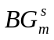is defined as the quintuple,
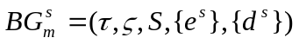
Where τ is all possible plaintexts formed using the ASCII table and ζ the corresponding cipher texts. S is all integer representations of binary values whose length is dividable by 4 and bigger or equal to 8 bits.

The encryption rule is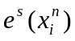where n is the amount of bits s consists of and i the index of every 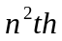 character in the text. For every x the characters are placed in a matrix of size with the first row being filled with the first n characters of x and the second with the next n and so forth. Thus a matrix 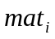is constructed which looks as follows
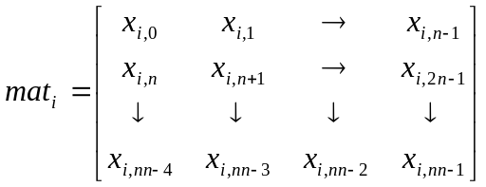
Next a sub key 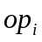 needs to be computed for each. This is done by examining the key. Every four bits starting from the least significant bit points to the lower four bits of a character on the main diagonal. The first four bits point to the first entry and so forth. When a one is found in the key the corresponding bit in the diagonal is stored as a bit in op. This search is conducted until 8 bits have been found or all the bits of the key have been checked. Now we have an 8 bit value. Next each’s transpose is taken and stored in. Now we compute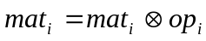accept on the values on the main diagonal. The entries in the matrices are now put back into a text string with the same method they were added, by starting with 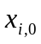 and ending with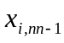. This whole text string is xor-ed with the least significant 8 bits of the key to conceal the main diagonals of the matrices. The text string that’s formed is the encoded text.

The decryption rule is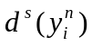. To decrypt the text first xor the cipher text with the 8 least significant bits of the key. Then construct all the matrices and compute all the sub keys. Now xor all the entries in the corresponding matrices with the sub key accept for the main diagonals. Lastly take the transpose of all the matrices and form a text string from the matrices as indicated above. This text is the deciphered text.

Please note that when there aren’t enough characters to fit into the last matrix when encoding pad the matrix with random values.
Key space

The key space associated with this cipher is computed as 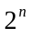where n is the amount of bits the key consists of. This key space is relatively small when small keys are chosen, for example a 16 bit encryption has only 65536 possible keys to search through. This however doesn’t present any problems because a person can easily make his key much larger. A brute force attack on a 128 bit encrypted text of length 4220 characters on my computer (3Ghz 64-bit CPU) will take roughly 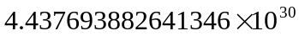 years to compute.

I therefore can conclude that Blue Glue has a suitable key space. Brute force attacks will be discussed in the part Cipher-attacks which follow later.
Protocol

- Always use the steps defined in the definition. If you are not sure also refer to the Matlab® code in Appendix A-D and also the example.

- Always make sure the key used is the correct length.

- Blue Glue doesn’t guarantee security, but the key you use with it does.

Example

To show how Blue Glue works I will encrypt and decrypt the message:
“This code works” with a 16-bit key 54488 which in binary notation is 1101010011011000.

Encrypt

This means we need one 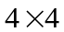matrix. The input text in ASCII is:
“84 104 105 115 32 99 111 100 101 32 119 111 114 107 115”
There needs to be one value padded to the end, I’ll use 87. The matrix is then constructed.

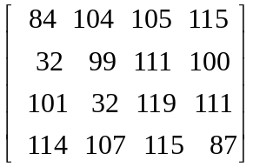

The transpose is worked out.

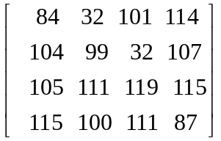

Next we need to compute the sub key. The values on the main diagonal are:
“84 99 119 87”

We split the key to see which bits we need,
84 99 119 87
1101 0100 1101 1000

I’ll show the diagonal bits as well

1010100 1100011 1110111 1010111
1101 0100 1101 1000
We need all the entries with corresponding ones, thus
01 0 0 01 1 0

The sub key is therefore 01000110 = 70 and xor-ing the matrix gives with the sub key gives:

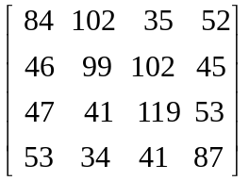

Lastly we xor this with the key’s 8 least significant bits 11010100 = 212.

This gives the following matrix:

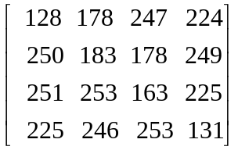

When we put this back into a text string the following cipher text is given:

“²÷àú·²ùûý£ááöý”

Decrypt
To decrypt we start by putting the message into a matrix:

We xor with the 8 least significant bits.

We work out the sub key 70 from the main diagonal.
Xor all the other values with 70.

Get the transpose.

And put it in a string:

“This code worksW”

It decrypted correctly.
Cipher-attacks

I computed on my computer how long it would take to run the decode algorithm on a text of length 4220 with a 16 bit encryption. I saw this took 0.4 seconds roughly and if you take the key space in to consideration it will take about 7 hours to crack the code.

This is not acceptable for companies who may lose a lot of money when the code is cracked. However as the amount of bits increases the security increases more and Blue Glue starts to shine. As I mentioned previously a 128 bit encryption will take years to crack. I can therefore say that Blue Glue can’t be cracked by brute force.

Logically the next step would be to see what happens when letter frequencies are taken.

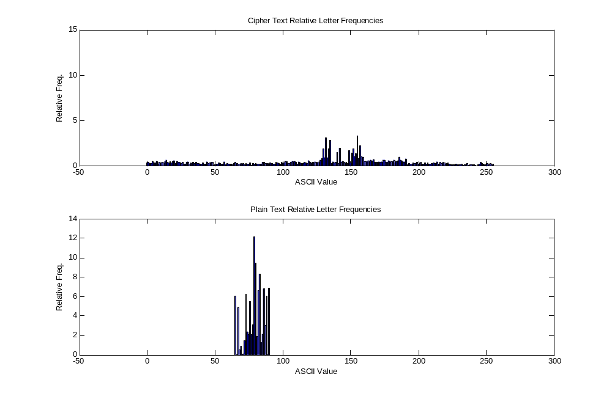
We see that the cipher text is nicely evened out over the whole ASCII table. There are a few values that have higher frequencies. I thought that maybe it will be possible to derive certain characters from those higher values. But this is not possible because every character is xor-ed with a value that is computed from n different other characters.

It is shown in the next graph how every character can go to different ASCII values.
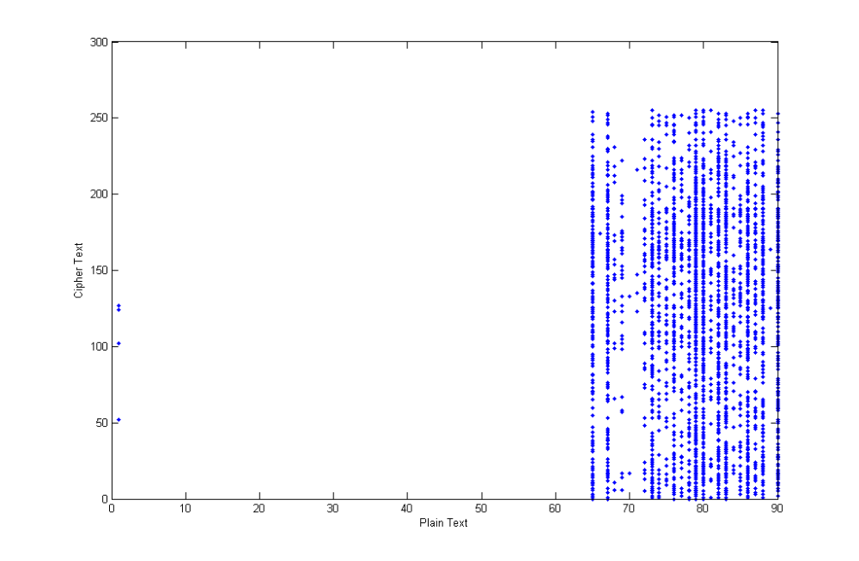
I can therefore also conclude that letter frequencies won’t work

So currently a method doesn’t exist to crack Blue Glue.

Advantages and disadvantages

Advantages
- Safe text is generated
- Numerically secure for big keys
- Letter frequencies give no information

Disadvantages
- Small keys relatively insecure
- May be possible methods to crack (see possible safety measures)
Possible Safety Measures

- When xor-ing with the 8 least significant bits of the key, rotate the bits by a certain amount

- Do more complicated matrix operations. Currently it’s very simple arithmetic

- Have a bit that defines if the sub key is computed from the lower or upper 4 bits.

- Restrict use to larger than 64 bit keys
Appendix A

This is a Matlab® function that generates a vector that contains the actual key and its amount of matrices needed. The input is a vector [0 1 0 1 0] where that will indicate 01010 in binary.

function [ret] = gen_key(key)
%return key in decimal and bit length divided by 4

s = size(key,2)/4;
key = bin2dec(num2str(key));
ret = [key s];
Appendix B

This is the Matlab® function that computes the sub key from the diagonal and the key. It returns the key when it’s calculated.

function [ret] = subkey(di,key)
%work out a sub key from a diagonal

di = di';
%index in bit
k=1;
%initialize bit
bit = zeros(1,8);
%get size
n = (size(di,2)*4);
%loop and get corresponding bits
for i=1:n
if bitget(key,n-i+1) == 1
bit(k) = bitget(di(ceil(i/4)),5-(mod(i-1,4)+1));
k = k+1;
end
end
%return bits
ret = bin2dec(num2str(bit));
Appendix C

This Matlab® code does the encoding of a piece of text as described in the definition.

function [ret] = encode(teks,key)
%encode kriptoteks using key from gen_key

s = key(2);
key = key(1);

vect = double(teks);
n = size(vect,2);
amount = ceil(n/s^2);
index = 0;

for i = 0:(amount-1)

%compute a matrix
for row = 1:s
for col = 1:s
if (s^2*i + col + s*(row - 1)) <= n
m(row,col) = vect(s^2*i + col + s*(row - 1));
else
m(row,col) = round(rand*255);
end
end
end

%do operations
op = subkey(diag(m),key);
m = m';
m = bitxor(m,op);
for i=1:s
m(i,i) = bitxor(m(i,i),op);
end
%add to encoded vector
for row = 1:s
for col = 1:s
index = index+1;
e_vect(index) = m(row,col);
end
end
end
ret = char(bitxor(e_vect,bitshift(key,-(8*(s/2-1)))));

Appendix D

This Matlab® code does the decoding of a piece of cipher text as described in the definition.

function [ret] = decode(kriptoteks,key)
%decode kriptoteks using key from gen_key

s = key(2);
key = key(1);

e_vect = bitxor(double(kriptoteks),bitshift(key,-(8*(s/2-1))));

n = size(e_vect,2);
amount = ceil(n/s^2);
index = 0;

for i = 0:(amount-1)

%compute a matrix
for row = 1:s
for col = 1:s
m(row,col) = e_vect(s^2*i + col + s*(row - 1));
end
end

%do operations
m = m';
op = subkey(diag(m),key);

m = bitxor(m,op);
for i=1:s
m(i,i) = bitxor(m(i,i),op);
end

%add to decoded vector
for row = 1:s
for col = 1:s
index = index+1;
vect(index) = m(row,col);
end
end
end
ret = char(vect);

